

**Server & Cloud Security**

## School of InfoComm Technology

Diploma in Information Security and Forensics

Diploma in Information Technology

**Practice Paper**

**Dec 2022**

Date:

Time:

INSTRUCTIONS TO CANDIDATES:

1. Write your Student Number, Name, Module Group and Seat Number CLEARLY in the boxes provided above.
2. This paper consists of 9 pages including this cover page. Check carefully to make sure your set is complete.
3. There are FIVE questions. Answer **ALL** questions.
4. Write your answers in the blank space provided for each question in this paper.

|  |  |
| --- | --- |
| **GRADE** |  |

* 1. Explain the various server roles in a 3-tier client-server architecture.

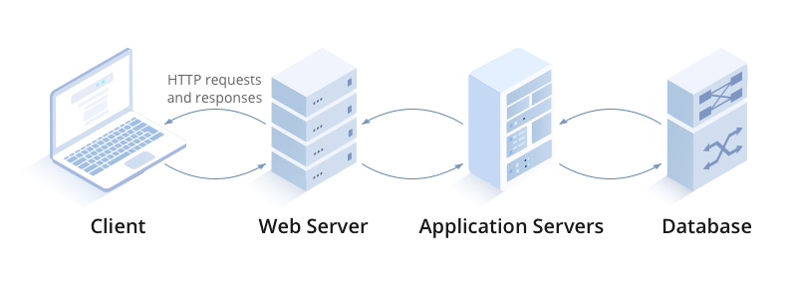

|  |
| --- |
|  |

* 1. With the aid of a well-labelled diagram, explain how a SYN flood attack exploits the TCP connection.

|  |
| --- |
|  |

* 1. Briefly explain what is disaster recovery and list THREE examples of disaster.

|  |
| --- |
|  |

* 1. The following steps were recommended to secure a server:
* Server hardening
* Secure the server network
* Manage Privileged Identities

1. For each of the recommended steps, list ONE reason why it should be performed.

|  |
| --- |
|  |

1. Describe TWO measures you would implement for each of the recommended steps.

|  |
| --- |
|  |

* 1. Company XYZ would like to have a cloud solution with a selection of OSs provisioned for exclusive use. Identify the cloud deployment model and cloud service model best suited for Company XYZ. Explain your answer.

|  |
| --- |
|  |

* 1. Discuss the shared responsibility models for IaaS, PaaS and SaaS.

|  |
| --- |
|  |

* 1. Discuss the differences between IAM users and roles.

|  |
| --- |
|  |

* 1. Briefly explain the differences between identity-based and resource-based policies in AWS IAM.

|  |
| --- |
|  |

* 1. Briefly explain the how the encryption keys are managed for the following ways of cloud data encryption:
* Client-side Encryption (CSE)
* SSE with customer-provided keys (SSE-C)
* SSE with Amazon S3 managed keys (SSE-S3)
* SSE with AWS KMS keys (SSE-KMS)

|  |
| --- |
|  |

* 1. Explain with reference to the below diagram on how AWS Certificate Manager helps to manage the digital certificate of the cloud consumer.

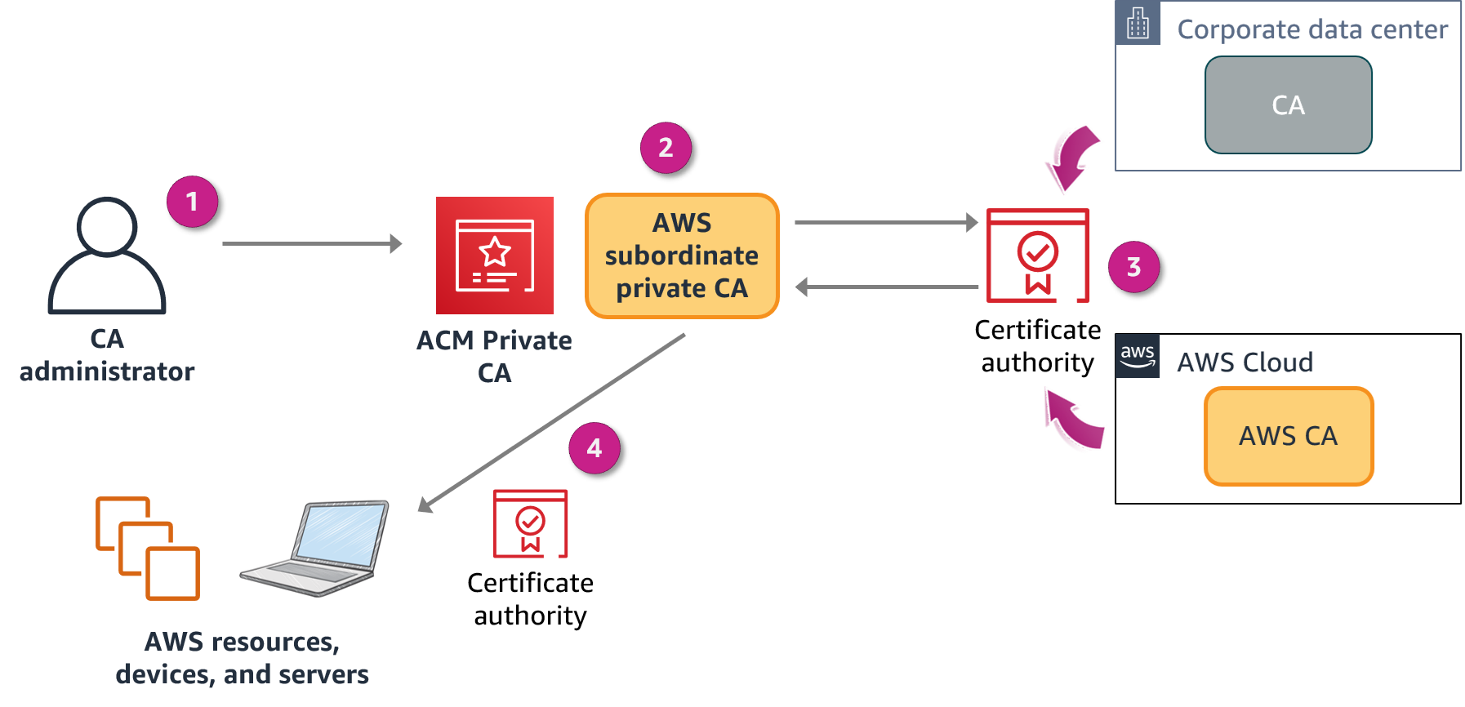

|  |
| --- |
|  |

* 1. Briefly explain the two focus areas of a matured security operations.

|  |
| --- |
|  |

* 1. Explain the TWO differences between AWS CloudTrail and CloudWatch.

|  |  |
| --- | --- |
| **AWS CloudTrail** | **Amazon CloudWatch** |
|  |  |
|  |  |

* 1. Briefly explain the two phases of incident response in AWS cloud operations.

|  |
| --- |
|  |

** END OF PAPER **